Name: ______________________________________________________________________________________________

Feelings Pumpkin

Write a feeling that goes with the zone in each box. Then draw a face on each pumpkin to show the feeling.

Green Zone Feeling: __________________________  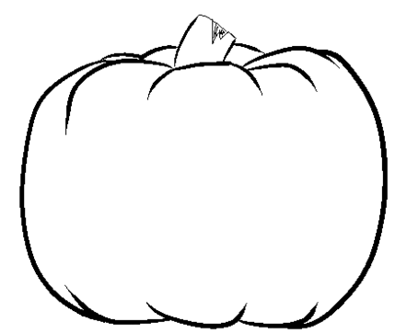 | Blue Zone Feeling: ____________________________
Yellow Zone Feeling: _________________________ | Red Zone Feeling: ____________________________

