Name: ______________________________________________________________________________________________

Feelings Pumpkin

Draw a face on each pumpkin to show the feeling.

HAPPY  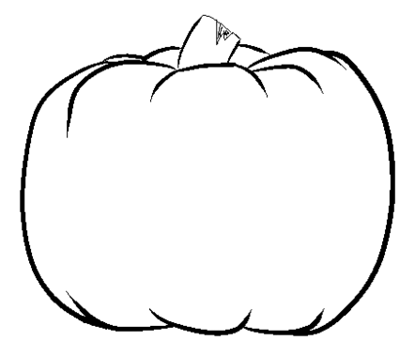 | SAD
SILLY | MAD

